Top NER Analysis and Word Cloud

Take a look at the demonstration website.

There are several named entity including PERSON, ORGANIZATION, FACILITY, LOCATION, GSP, and GPE.

In this tutorial we will display and chart the top keywords with different named entity and with different category on our Django website.

There is only one new thing we should learn to do: charting word cloud using D3.js!

http://163.18.23.21:8001/topner/
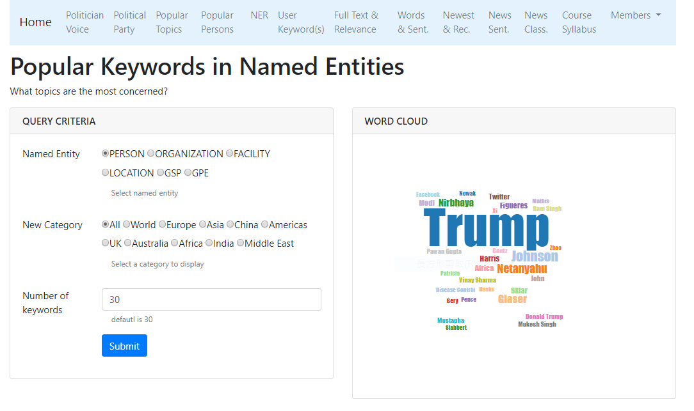
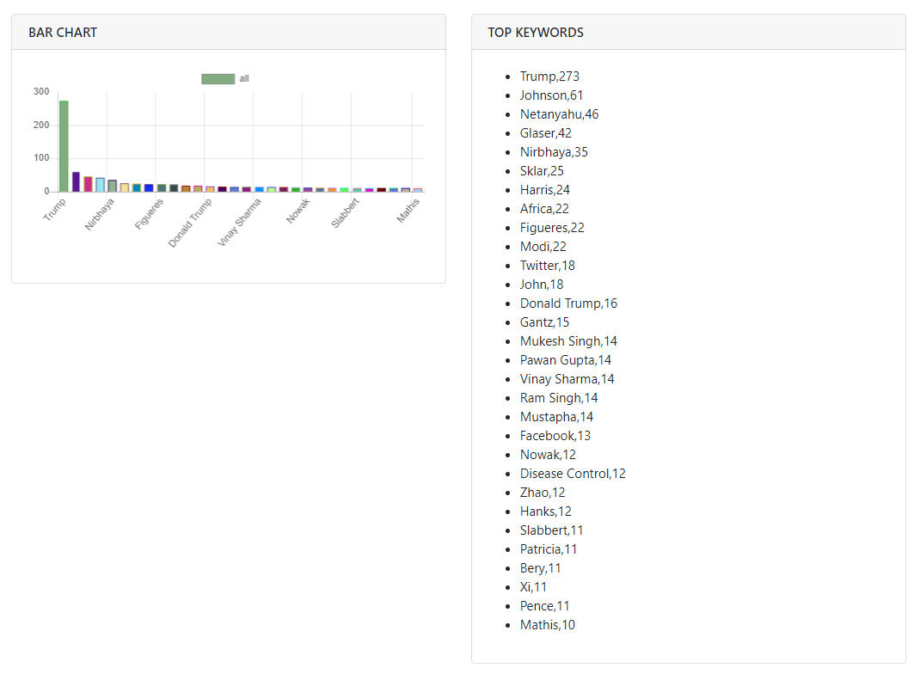

http://163.18.23.21:8000/topner/
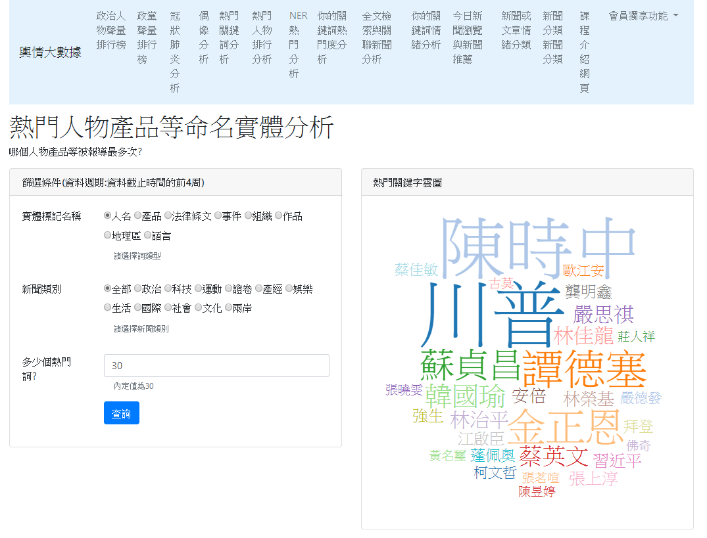

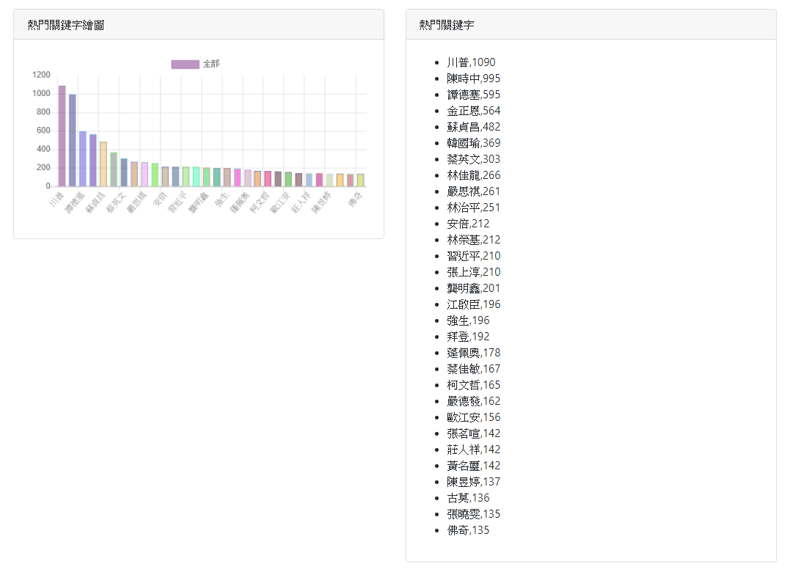

Development tools
In this class, we use “VS Code.” However, you can use PyCharm, Sublime, Atom, Notepad++, vi, vim, or any other favorite editor.

Step 0: Create a project “site_news_analysis_v3”

We will continue from our previous project.

Create a folder “site_news_analysis_v3” by duplicating the folder “site_news_analysis_v2”

I suggest you rename your project folder with a meaningful name such as:
“site_news_analysis_v3_top_keyword_ner”

Step1: Open the project with your favorite Editor
Now let’s open project using VS Code.

Step 2: Create “app_top_ner” app
Step 2: Create a new APP in your website root.

python manage.py startapp app_top_ner

Step3: Copy csv data to the dataset folder

app_top_ner/dataset/news_topkey_by_ne_and_category.csv

Step 4: settings.py
ALLOWED_HOSTS = ['localhost', '127.0.0.1']

INSTALLED_APPS = [
…..
' app_top_keyword',
' app_top_person',
'app_top_ner',
]

TEMPLATES = [
{
'BACKEND': 'django.template.backends.django.DjangoTemplates',
'DIRS': [os.path.join(BASE_DIR, 'templates')],
'APP_DIRS': True,
'OPTIONS': …..
……
……
},
]

Step 5: website_configs/urls.py

website_configs/urls.py
from django.urls import path
from django.urls import include

urlpatterns = [
# app top keywords
path('topword/', include('app_top_keyword.urls')),
# app top persons
path('topperson/', include('app_top_person.urls')),
# top ner
path('topner/', include('app_top_ner.urls')),
]

Step 6: app_top_ner/urls.py
In folder app_top_ner, create a Python file named “urls.py”.

app_top_ner/urls.py
from django.urls import path
from app_top_ner import views

app_name="app_top_ner"

urlpatterns = [
path('', views.home, name='home'),
path('api_get_ner_topword/', views.api_get_ner_topword),
]

Step 7: views.py
- Load data
- Prepare index to NE and category names (dict format)
- Define home and Api

The dataset for NER analysis is located in the following folder:
app_top_ner/dataset/news_topkey_by_ner_and_category.csv

views.py
from django.shortcuts import render
import pandas as pd

from django.http import JsonResponse
from django.views.decorators.csrf import csrf_exempt

'''
{'CARDINAL': {'政治': [('2020', 249),
('10', 170),
('15', 113),
('13', 105),
...
}
'''

# ne names
ne_name =['EVENT','FAC','GPE','LANGUAGE','LAW','LOC','NORP','ORG','PERSON','PRODUCT','WORK_OF_ART']
idx2nename = { str(i) : item for i, item in enumerate(ne_name)}
'''
{0: 'EVENT',
1: 'FAC',
2: 'GPE',
3: 'LANGUAGE',
4: 'LAW',
5: 'LOC',
6: 'NORP',
7: 'ORG',
8: 'PERSON',
9: 'PRODUCT',
10: 'WORK_OF_ART'}

Name Description
CARDINAL 數字
DATE 日期
EVENT 事件
FAC 設施
GPE 行政區
LANGUAGE 語言
LAW 法律
LOC 地理區
MONEY 金錢
NORP 民族、宗教、政治團體
ORDINAL 序數
ORG 組織
PERCENT 百分比率
PERSON 人物
PRODUCT 產品
QUANTITY 數量
TIME 時間
WORK_OF_ART 作品

'''

# category names
news_categories=['政治','科技','運動','證卷','產經','娛樂','生活','國際','社會','文化','兩岸','全部']
idx2cate = { str(i) : item for i, item in enumerate(news_categories)}
'''
{'0': '政治',
'1': '科技',
'2': '運動',
'3': '證卷',
'4': '產經',
'5': '娛樂',
'6': '生活',
'7': '國際',
'8': '社會',
'9': '文化',
'10': '兩岸',
'11': '全部'}
'''
def load_data_topNer():
# read data
df_data= pd.read_csv('app_top_ner/dataset/news_topkey_by_ner_and_category.csv')

global data
data = {}
for idx, (nerName, topKeys) in df_data.iterrows():
data[nerName] = dict(eval(topKeys))

# We should call load_data() at first.
load_data_topNer()

def home(request):
return render(request,'app_top_ner/home.html')

# When Post is used, the csrf of this function should be ignored
@csrf_exempt
def api_get_ner_topword(request):
# POST方式取得新聞類別
cate = request.POST.get('news_category')
cate = idx2cate[cate]

# 取得多少筆關鍵詞
topk = int(request.POST.get('topk'))

ner_value = request.POST.get('ner_value')
ner_value = idx2nename[ner_value]

print(ner_value, cate, topk)

responseData = get_category_topkey(ner_value, cate, topk)
response = {'data': responseData }
print(response)
return JsonResponse(response)

# Cloud chart
# text size based on the value of word frequency for drawing cloud chart
'''
clouddata=[{
'text': '台北市',
'size': 40
},
{
'text': '高雄市',
'size': 15
},
{
'text': '台北市',
'size': 25
}]
'''

def get_category_topkey(ner_value, cate, topk):

wf_pairs = data[ner_value][cate][0:topk]

if wf_pairs == []:
return []

words = [w for w, f in wf_pairs]
freqs = [f for w, f in wf_pairs]

# Prepare cloud chart data
# the minimum and maximum frequency of top words
min_ = wf_pairs[-1][1] # the last line is smaller
max_ = wf_pairs[0][1] # the first frequency value is larger

textSizeMin = 10
textSizeMax = 90

if (min_ != max_):
max_min_range = max_ - min_

else:
max_min_range = len(wf_pairs)
min_ = min_ - 1

# cloud chart data
# using proportional scaling
clouddata = [{'text':w, 'size':int(textSizeMin+(f - min_)/max_min_range*(textSizeMax-textSizeMin))} for w, f in wf_pairs]

responseData = {
"wf_pairs": wf_pairs,
"data_barchart":{
"category": cate,
"labels": words,
"values": freqs
},
"data_cloud": clouddata}
return responseData

print("app_top_ner載入成功!")

Step 8: HTML (Template)

In the app folder, create an HTML file named “home.html”

app_top_ner/templates/app_top_ner/home.html

{% extends 'base.html' %} {% block title %}
熱門命名實體
{% endblock %} {% block content %}
<div class="col-lg-12">
<h1>熱門人物產品等命名實體分析</h1>
<p>哪個人物產品等被報導最多次?</p>
</div>
<!-- query criteria col-lg-6 card -->
<div class="col-lg-6 mb-5">
<div class="card">
<div class="card-header">
<h3 class="h6 text-uppercase mb-0">篩選條件(資料週期:資料截止時間的前4周)</h3>
</div>
<div class="card-body">
<!-- NE names -->
<div class="mb-3 row">
<label class="col-sm-3 col-form-label">實體標記名稱</label>
<div class="col-md-9 mb-3">
<div class="form-check form-check-inline">
<input class="form-check-input" type="radio" value="8" name="nerradio" id="ner8" checked />
<label class="form-check-label" for="ner8">人名</label>
</div>
<div class="form-check form-check-inline">
<input class="form-check-input" type="radio" value="9" name="nerradio" id="ner9" />
<label class="form-check-label" for="ner9">產品</label>
</div>
<div class="form-check form-check-inline">
<input class="form-check-input" type="radio" value="4" name="nerradio" id="ner4" />
<label class="form-check-label" for="ner4">法律條文</label>
</div>
<div class="form-check form-check-inline">
<input class="form-check-input" type="radio" value="0" name="nerradio" id="ner0" />
<label class="form-check-label" for="ner0">事件</label>
</div>
<div class="form-check form-check-inline">
<input class="form-check-input" type="radio" value="7" name="nerradio" id="ner7" />
<label class="form-check-label" for="ner7">組織</label>
</div>
<div class="form-check form-check-inline">
<input class="form-check-input" type="radio" value="10" name="nerradio" id="ner10" />
<label class="form-check-label" for="ner10">作品</label>
</div>
<div class="form-check form-check-inline">
<input class="form-check-input" type="radio" value="5" name="nerradio" id="ner5" />
<label class="form-check-label" for="ner5">地理區</label>
</div>
<div class="form-check form-check-inline">
<input class="form-check-input" type="radio" value="3" name="nerradio" id="ner3" />
<label class="form-check-label" for="ner3">語言</label>
</div>
<div class="form-text text-muted ms-3">請選擇詞類型</div>
</div>
</div>
<!-- form group -->
<!-- new category form group -->
<div class="mb-3 row">
<label class="col-sm-3 col-form-label">新聞類別</label>
<div class="col-md-9 mb-3">
<div class="form-check form-check-inline">
<input class="form-check-input" type="radio" value="0" name="cateradio" id="cate0" checked />
<label class="form-check-label" for="cate0">政治</label>
</div>
<div class="form-check form-check-inline">
<input class="form-check-input" type="radio" value="1" name="cateradio" id="cate1" />
<label class="form-check-label" for="cate1">科技</label>
</div>
<div class="form-check form-check-inline">
<input class="form-check-input" type="radio" value="2" name="cateradio" id="cate2" />
<label class="form-check-label" for="cate2">運動</label>
</div>
<div class="form-check form-check-inline">
<input class="form-check-input" type="radio" value="3" name="cateradio" id="cate3" />
<label class="form-check-label" for="cate3">證卷</label>
</div>
<div class="form-check form-check-inline">
<input class="form-check-input" type="radio" value="4" name="cateradio" id="cate4" />
<label class="form-check-label" for="cate4">產經</label>
</div>
<div class="form-check form-check-inline">
<input class="form-check-input" type="radio" value="5" name="cateradio" id="cate5" />
<label class="form-check-label" for="cate5">娛樂</label>
</div>
<div class="form-check form-check-inline">
<input class="form-check-input" type="radio" value="6" name="cateradio" id="cate6" />
<label class="form-check-label" for="cate6">生活</label>
</div>
<div class="form-check form-check-inline">
<input class="form-check-input" type="radio" value="7" name="cateradio" id="cate7" />
<label class="form-check-label" for="cate7">國際</label>
</div>
<div class="form-check form-check-inline">
<input class="form-check-input" type="radio" value="8" name="cateradio" id="cate8" />
<label class="form-check-label" for="cate8">社會</label>
</div>
<div class="form-check form-check-inline">
<input class="form-check-input" type="radio" value="9" name="cateradio" id="cate9" />
<label class="form-check-label" for="cate9">文化</label>
</div>
<div class="form-check form-check-inline">
<input class="form-check-input" type="radio" value="10" name="cateradio" id="cate10" />
<label class="form-check-label" for="cate10">兩岸</label>
</div>
<div class="form-check form-check-inline">
<input class="form-check-input" type="radio" value="11" name="cateradio" id="cate11" />
<label class="form-check-label" for="cate11">全部</label>
</div>
<div class="form-text text-muted ms-3">請選擇新聞類別</div>
</div>
</div>
<!-- Select number of words -->
<div class="mb-3 row">
<label class="col-md-3 col-form-label">多少個熱門詞?</label>
<div class="col-md-9">
<input id="topk_keys" name="topk" value="30" class="form-control" />
<div class="form-text text-muted ms-3">內定值為30</div>
</div>
</div>
<!-- submit -->
<div class="mb-3 row">
<div class="col-md-9 ms-auto">
<button type="button" id="btn_ok" class="btn btn-primary">查詢</button>
</div>
</div>
</div>
<!-- card body -->
</div> <!-- card -->
</div> <!-- column -->
<!-- draw cloud chart -->
<div class="col-lg-6 mb-5">
<div class="card">
<div class="card-header">
<h3 class="h6 text-uppercase mb-0">熱門關鍵字雲圖</h3>
</div>
<div class="card-body">
<div id="cloud"></div>
</div>
</div>
</div>
<!-- column -->
<!-- draw chart -->
<div class="col-lg-6 mb-5">
<div class="card">
<div class="card-header">
<h3 class="h6 text-uppercase mb-0">熱門關鍵字繪圖</h3>
</div>
<div class="card-body">
<canvas id="mychart"></canvas>
</div>
</div>
</div>
<!-- column -->
<!-- display top words -->
<div class="col-lg-6 mb-5">
<div class="card">
<div class="card-header">
<h3 class="h6 text-uppercase mb-0">熱門關鍵字</h3>
</div>
<div class="card-body">
<ul id="topkeys"></ul>
</div>
</div>
</div>
<!-- column -->
{% endblock %} {% block extra_js %}
<!-- chartjs js -->
<script src="https://cdnjs.cloudflare.com/ajax/libs/Chart.js/2.7.3/Chart.min.js"></script>
<!-- word cloud chart ====
Here is the cloud chart script.
reference:http://bl.ocks.org/joews/9697914
reference:https://jsfiddle.net/x827g61m/
reference:https://www.d3-graph-gallery.com/wordcloud
src="https://rawgit.com/jasondavies/d3-cloud/master/build/d3.layout.cloud.js">
-->
<script src="https://cdnjs.cloudflare.com/ajax/libs/d3/3.4.11/d3.min.js"></script>
<script src="https://cdn.rawgit.com/jasondavies/d3-cloud/v1.2.1/build/d3.layout.cloud.js"></script>

<!-- Here are your js code -->
<script>
// Show the page with default setting when page is initialized.
call_ajax()

//** submit event
$('#btn_ok').on('click', function () {
call_ajax()
}) //event function

$("input[name='cateradio']").on('change', function () {
call_ajax()
}) //event function

$("input[name='nerradio']").on('change', function () {
call_ajax()
}) //event function

function call_ajax() {
// get user's input
const ner_value = $("input[name='nerradio']:checked").val()
console.log(ner_value)

const cate = $("input[name='cateradio']:checked").val()

var topk = $('#topk_keys').val()
console.log(topk)

// send and get data
$.ajax({
type: 'POST',

url: '/topner/api_get_ner_topword/',
data: {
news_category: cate,
topk: topk,
ner_value: ner_value
},
success: function (received) {
// clear previous top words
$('#topkeys').empty()
// clear previous cloud chart
$('#cloud').empty()

console.log(received.data)
if (received.data.length == 0) {
$('#cloud').append('<h4>No Data!</h4>')
$('#topkeys').append('<h4>No Data!</h4>')
return
}

const data_barchart = received.data.data_barchart
showChart(data_barchart)

const wf_pairs = received.data.wf_pairs
showTopKeys(wf_pairs)

topWordToDraw = received.data.data_cloud
drawCloud(topWordToDraw, '#cloud')
} //ajax function
}) //ajax
} //call_ajax

//* 顯示關鍵詞資料函數
function showTopKeys(items) {
//先清除前一次的資料
$('#topkeys').empty()

//將內容加上li標籤附加起來，顯示在顯示區"topkeys"
for (let i = 0; i < items.length; i++) {
let item_li = '<li>' + items[i] + '</li>'
$('#topkeys').append(item_li)
}
} //function

//**繪圖函數showChart()
function showChart(chart_data) {
// 畫圖需要的數據資料
let values = chart_data.values
let labels = chart_data.labels
let category = chart_data.category

//第1個變數: 餵給chart的資料
let data = {
labels: labels,
datasets: [
{
label: category,
data: values,
backgroundColor: randomColors(values.length),
borderColor: randomColors(values.length),
borderWidth: 1
}
]
}

//第2個變數: chart的選項 指定y坐標軸從零開始顯示
let options = {
scales: {
yAxes: [
{
ticks: {
beginAtZero: true
}
}
]
}
}

//取得在前面html區域欲顯示的圖代號
let canvas_mychrat = document.getElementById('mychart')

//**先清除前一個圖 再繪新圖
// 可以印出barchart物件是否存在
// console.log(window.barchart);
//先清除前一個圖 再繪新圖 if 有以下兩種寫法皆可
// if (window.barchart) //若存在則為true
// if (typeof (barchart) != "undefined"){
if (window.barchart) {
barchart.destroy()
}

//**繪圖(產生一個圖物件變數名稱為barchart)
// 必須全域變數--注意:前面不要有let, var, const等修飾詞
// 理由: 我們要讓它存在於網頁全域變數，
// 這樣我們才方便判斷是否有前一次的圖，如果存在有，要刪除之，否則，很多張圖會疊在一起
barchart = new Chart(canvas_mychrat, {
type: 'bar',
data: data,
options: options
})

//** 產生隨機顏色
function randomColors(num_colors) {
let colors = []

for (let i = 0; i < num_colors; i++) {
let r = Math.floor(Math.random() * 255)
let g = Math.floor(Math.random() * 255)
let b = Math.floor(Math.random() * 255)
let rgb = `rgba(${r},${g},${b},0.5)` // (red, green, blue, alfa) alfa透明度

colors.push(rgb)
}
return colors
}
} //show chart function

//** cloud chart
function drawCloud(topWordToDraw, element_id) {
// You should set a proper box size to show cloud chart
const width = 400
const height = 400

// First define your cloud data, using `text` and `size` properties:
// Next you need to use the layout script to calculate the placement, rotation and size of each word:
// Constructs a new cloud layout instance.
d3.layout
.cloud()
.size([width, height])
.words(topWordToDraw) //data for cloud chart
.rotate(function () {
//return ~~(Math.random() * 2) * 90; //~~1.5 => 1 (same as Math.floor(1.5))
return 30 // don't rotate
})
.font('Impact')
.fontSize(function (d) {
return d.size
})
.on('end', draw) //call function draw()
.start()

// Finally implement `draw`, which performs the D3 drawing
// This function takes the output of 'layout' above and draw the words
function draw(words) {
const fill = d3.scale.category20()

// append the svg object to the body of the page
d3.select(element_id)
.append('svg') // element_id such as "#cloud"
.attr('width', width)
.attr('height', height)
.append('g')
.attr('transform', 'translate(' + ~~(width / 2) + ',' + ~~(height / 2) + ')')
.selectAll('text')
.data(words)
.enter()
.append('text')
.style('font-size', function (d) {
return d.size + 'px'
})
.style('-webkit-touch-callout', 'none')
.style('-webkit-user-select', 'none')
.style('-khtml-user-select', 'none')
.style('-moz-user-select', 'none')
.style('-ms-user-select', 'none')
.style('user-select', 'none')
.style('cursor', 'default')
.style('font-family', 'Impact')
.style('fill', function (d, i) {
return fill(i)
})
.attr('text-anchor', 'middle')
.attr('transform', function (d) {
return 'translate(' + [d.x, d.y] + ')rotate(' + d.rotate + ')'
})
.text(function (d) {
return d.text
})
} //draw
} //drawCloud()
</script>
{% endblock %}

Add NEs in the QUERY CRITERIA

For CNA news (中央社)
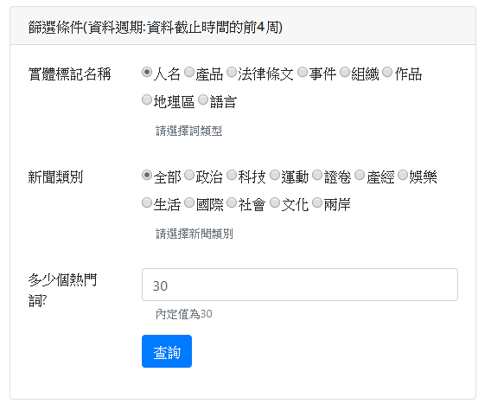

Add a card area for displaying word cloud chart

Notice that the <div id="cloud"></div> is very import. The element id '#cloud' will be used later in the Ajax function and word cloud chart.

For CNA news (中央社)
<!-- draw cloud chart -->
<div class="col-lg-6 mb-5">
<div class="card">
<div class="card-header">
<h3 class="h6 text-uppercase mb-0">熱門關鍵字雲圖</h3>
</div>
<div class="card-body">
<div id="cloud"></div>
</div>
</div>
</div><!-- column -->

Step 9: base.html

For CNA news (中央社)
<a class="nav-link" href="{% url 'app_top_ner:home' %}">NER熱門分析</a>

Step 10: Run server

python manage.py runserver 8000

What does the web page look like?

Step 11: JavaScript

Load JS Library
It is the same as previous apps.
<!-- chartjs js-->
<script src="https://cdnjs.cloudflare.com/ajax/libs/Chart.js/2.7.3/Chart.min.js"></script>
<!-- word cloud chart ====
Here is the cloud chart script.
reference:http://bl.ocks.org/joews/9697914
reference:https://jsfiddle.net/x827g61m/
reference:https://www.d3-graph-gallery.com/wordcloud
src="https://rawgit.com/jasondavies/d3-cloud/master/build/d3.layout.cloud.js">
-->
<script src="https://cdnjs.cloudflare.com/ajax/libs/d3/3.4.11/d3.min.js"></script>
<script src="https://cdn.rawgit.com/jasondavies/d3-cloud/v1.2.1/build/d3.layout.cloud.js"></script>

<!-- Here are your js code -->
<script>

</script>

Define event function
// Show the page with default setting when page is initialized.
call_ajax();

//** submit event
$('#btn_ok').on('click', function () {
call_ajax();
}); //event function

$("input[name='cateradio']").on('change', function () {
call_ajax();
}); //event function

$("input[name='nerradio']").on('change', function () {
call_ajax();
}); //event function

Define Ajax function

Compare to your previous app, only these things are different:
- In additional to “news_category” and “topk”, the views.py need to know “ner_value”. Therefore the data in the ajax will be the following:

data: {
"news_category": cate,
"topk": topk,
"ner_value": ner_value,
},

- Get the data for charting: topWordToDraw = received.data.data_cloud;
- Draw the cloud chart: drawCloud(topWordToDraw, '#cloud');

Ajax function is as follows.
function call_ajax() {
//var call_ajax = function() {
// get user's input
const ner_value = $("input[name='nerradio']:checked").val();
console.log(ner_value);

const cate = $("input[name='cateradio']:checked").val();

var topk = $('#topk_keys').val();
console.log(topk);

// send and get data
$.ajax({
type: "POST",

url: "/topner/api_get_ner_topword/",
//url: "http://127.0.0.1:8000/topner/api_get_ner_topword/",
data: {
"news_category": cate,
"topk": topk,
"ner_value": ner_value,
},
success: function (received) {

// clear previous top words
$('#topkeys').empty();
// clear previous cloud chart
$('#cloud').empty();

console.log(received.data);
if (received.data.length == 0) {
$('#cloud').append("<h4>No Data!</h4>");
$('#topkeys').append("<h4>No Data!</h4>");
return
}

const data_barchart = received.data.data_barchart;
showChart(data_barchart);

const wf_pairs = received.data.wf_pairs;
showTopKeys(wf_pairs);

topWordToDraw = received.data.data_cloud;
drawCloud(topWordToDraw, '#cloud');

} //ajax function
}); //ajax
} //call_ajax

Functions of Show Top Keywords and Draw Bar Chart
//* 顯示關鍵詞資料函數
function showTopKeys(items) {
//先清除前一次的資料
$('#topkeys').empty();

//將內容加上li標籤附加起來，顯示在顯示區"topkeys"
for (let i = 0; i < items.length; i++) {
let item_li = "<li>" + items[i] + "</li>";
$('#topkeys').append(item_li);
}
} //function

//**繪圖函數showChart()
function showChart(chart_data) {

// 畫圖需要的數據資料
let values = chart_data.values;
let labels = chart_data.labels;
let category = chart_data.category;

//第1個變數: 餵給chart的資料
let data = {
labels: labels,
datasets: [{
label: category,
data: values,
backgroundColor: randomColors(values.length),
borderColor: randomColors(values.length),
borderWidth: 1,
}],
};

//第2個變數: chart的選項 指定y坐標軸從零開始顯示
let options = {
scales: {
yAxes: [{
ticks: {
beginAtZero: true
}
}]
},
};

//取得在前面html區域欲顯示的圖代號
let canvas_mychrat = document.getElementById("mychart");

//**先清除前一個圖 再繪新圖
// 可以印出barchart物件是否存在
// console.log(window.barchart);
//先清除前一個圖 再繪新圖 if 有以下兩種寫法皆可
// if (window.barchart) //若存在則為true
// if (typeof (barchart) != "undefined"){
if (window.barchart) {
barchart.destroy();
}

//**繪圖(產生一個圖物件變數名稱為barchart)
// 必須全域變數--注意:前面不要有let, var, const等修飾詞
// 理由: 我們要讓它存在於網頁全域變數，
// 這樣我們才方便判斷是否有前一次的圖，如果存在有，要刪除之，否則，很多張圖會疊在一起
barchart = new Chart(canvas_mychrat, {
type: 'bar',
data: data,
options: options,
});

//** 產生隨機顏色
function randomColors(num_colors) {
let colors = [];

for (i = 0; i < num_colors; i++) {

let r = Math.floor(Math.random() * 255);
let g = Math.floor(Math.random() * 255);
let b = Math.floor(Math.random() * 255);
let rgb = `rgba(${r},${g},${b},0.5)` // (red, green, blue, alfa) alfa透明度

colors.push(rgb);
}
return colors;
}

} //show chart function

Function of drawing word cloud
The Javascript charting codes are very complicated. To understand the detail charting parameters, you should refer to the official documents.

To draw the word cloud, we should input the following two things:
- topWordToDraw: keywords and values for charting, it is obtained from the backend views.py
- element_id: “#cloud” is the element id where we draw chart on it.

They are used in the next Ajax function as follows.

topWordToDraw = received.data.data_cloud; //receive data from backend
drawCloud(topWordToDraw, '#cloud'); //call drawCloud to draw chart

To draw the word cloud, we need to import the d3.js as follows.

Here is the cloud chart script.
reference:http://bl.ocks.org/joews/9697914
reference:https://jsfiddle.net/x827g61m/
reference:https://www.d3-graph-gallery.com/wordcloud

Define drawCloud() function as follows.
//** cloud chart
function drawCloud(topWordToDraw, element_id) {
// You should set a proper box size to show cloud chart
const width = 400;
const height = 400;

// First define your cloud data, using `text` and `size` properties:
// Next you need to use the layout script to calculate the placement, rotation and size of each word:
// Constructs a new cloud layout instance.
d3.layout.cloud()
.size([width, height])
.words(topWordToDraw) //data for cloud chart
.rotate(function () {
//return ~~(Math.random() * 2) * 90; //~~1.5 => 1 (same as Math.floor(1.5))
return 0; // don't rotate
})
.font("Impact")
.fontSize(function (d) {
return d.size;
})
.on("end", draw) //call function draw()
.start();

// Finally implement `draw`, which performs the D3 drawing
// This function takes the output of 'layout' above and draw the words
function draw(words) {

const fill = d3.scale.category20();

// append the svg object to the body of the page
d3.select(element_id).append("svg") // element_id such as "#cloud"
.attr("width", width)
.attr("height", height)
.append("g")
.attr("transform", "translate(" + ~~(width / 2) + "," + ~~(height / 2) + ")")
.selectAll("text")
.data(words)
.enter().append("text")
.style("font-size", function (d) {
return d.size + "px";
})
.style("-webkit-touch-callout", "none")
.style("-webkit-user-select", "none")
.style("-khtml-user-select", "none")
.style("-moz-user-select", "none")
.style("-ms-user-select", "none")
.style("user-select", "none")
.style("cursor", "default")
.style("font-family", "Impact")
.style("fill", function (d, i) {
return fill(i);
})
.attr("text-anchor", "middle")
.attr("transform", function (d) {
return "translate(" + [d.x, d.y] + ")rotate(" + d.rotate + ")";
})
.text(function (d) {
return d.text;
});
} //draw
} //drawCloud()

